CANADIAN POWER AND SAIL SQUADRONS • VOYAGEUR DISTRICTCT
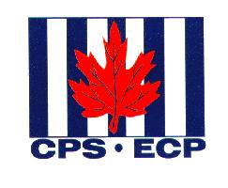

Bracebridge • Huntsville • North Bay • North Channel • Parry Sound • Sault Ste Marie • Sudbury •Tri-Town

Commander
Elizabeth Appleton
1193 Premier Rd.
North Bay, ON P1A 2J3
Tel. (705) 476-0364
e.appleton@cogeco.ca
Patron
HRH The Prince Philip
Duke of Edinburgh
KG, KT
